Sujata Rai

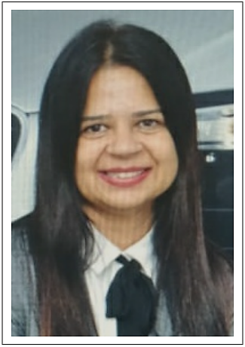

Sujata Rai is a Senior HR Leader with an experience of over 23 years of working with reputed IT and ITes Companies such as Volkswagen IT Services, Saama Technologies, HCL Technologies (erstwhile Geometric Software), Aegis Ltd (Essar Group), Ness Technologies.
She is a qualified and proficient HR professional with a Master’s in Personnel Management (M.P.M) and Diploma in Labor Law & Labor Welfare (D.L.L) from Pune University.
She has extensive experience in the various facets of Human Resources such as HRM, Strategic Operations, Talent Acquisition, Talent Management, Leadership Development, Succession Planning, Organization Development and Change Management.
She is highly adept at leading HR audits as she has conducted HR process audits across Geometric Software’s Pan India locations.
She concurrently held position of Diversity Manager in Aegis Ltd., (and Essar Group Company) for Pan India locations, and her efforts towards recruitment of people from diverse backgrounds have been recognized both internally and externally.
During her tenure as Director HR, Saama Technologies received the prestigious Global HR Excellence Awards in Year 2016 organized by the World HRD Congress, under 2 categories - ‘Best HR Organization to Work For’ & ‘Organization with Innovative HR practices’.
She is a Certified trainer for Competency Based Interviewing.
She is a Certified administrator in psychometric testing - DISC.

Key capabilities lie in design and deployment of:

- HR Policies & Process Improvement

- Talent Acquisition

- Talent Management

- Competency Mapping

- Leadership Development

- Succession Planning

- Organization Development

- Statutory Compliances

- Change Management

